**SHELL SCRIPT ASSIGNMENT**

**1. Create a script named “myscript” in current directory to do the following.**

**a) display “hello user”**

**A: Command----** ./myscript.sh

**b) list files in current directory**

**A: Command---** ll

**c) name of logged in user**

**A: Command---** who am i

**d) date**

**2. Add execute permission and Run the script from**

**a) current directory**

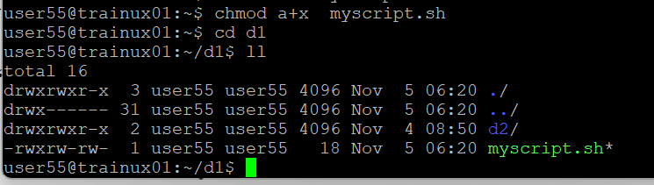

**3. Create a subdirectory named “test”**

**4. Change to “test” directory. Run the script “myscript” [Hint: You will have to update PATH to include the directory containg script to run script from any location].**

**A: Commad---** ../myscript.sh

